Name of Student: HARPAL BIDAWAT | PRN:25070122080
Semester: III | Year : AY 2026-27
Subject: Programming with Java
ASSIGNMENT No : 22
TITLE : JDBC PreparedStatement, and ResultSet
Problem Statement
Demonstration and exploration of JDBC classes and interfaces (PreparedStatement, and ResultSet).
Learning Objectives
To implement PreparedStatement and ResultSet for secure query execution and data retrieval.

Programme
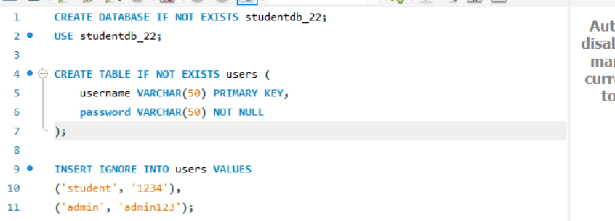
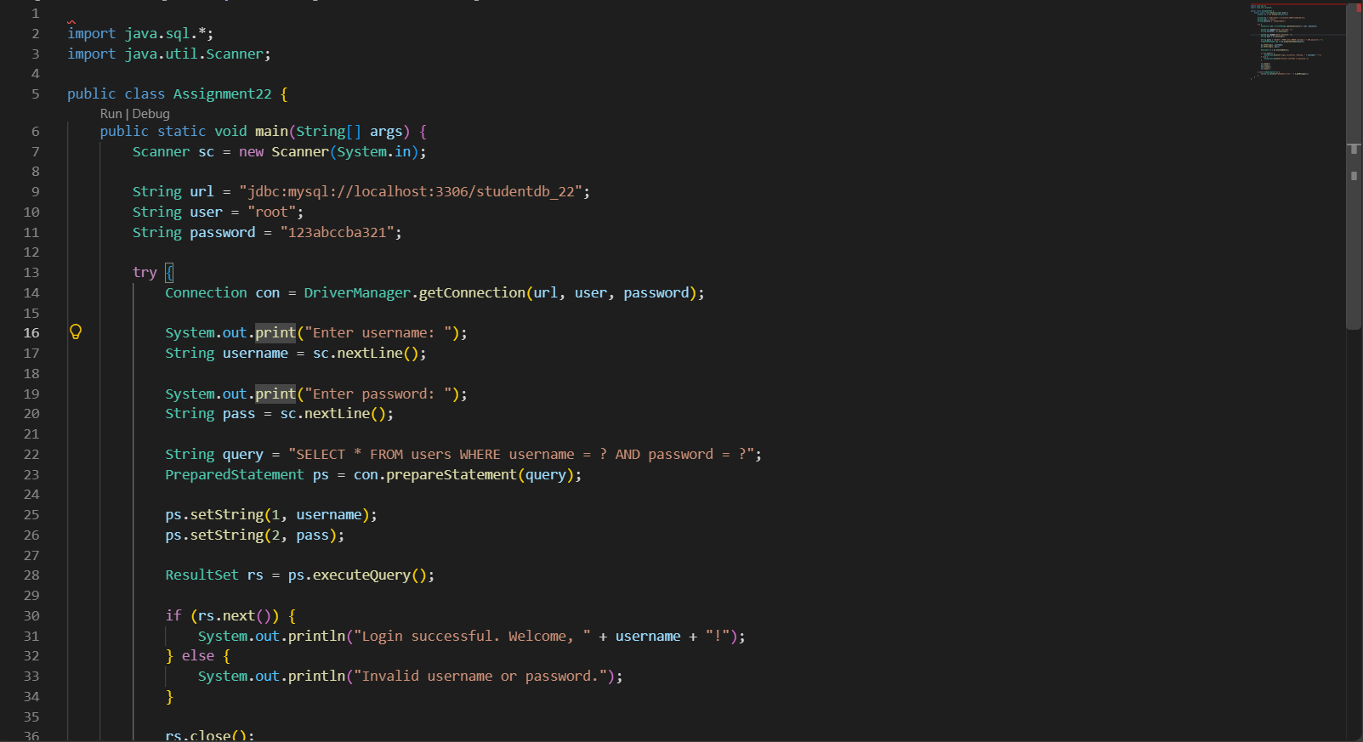
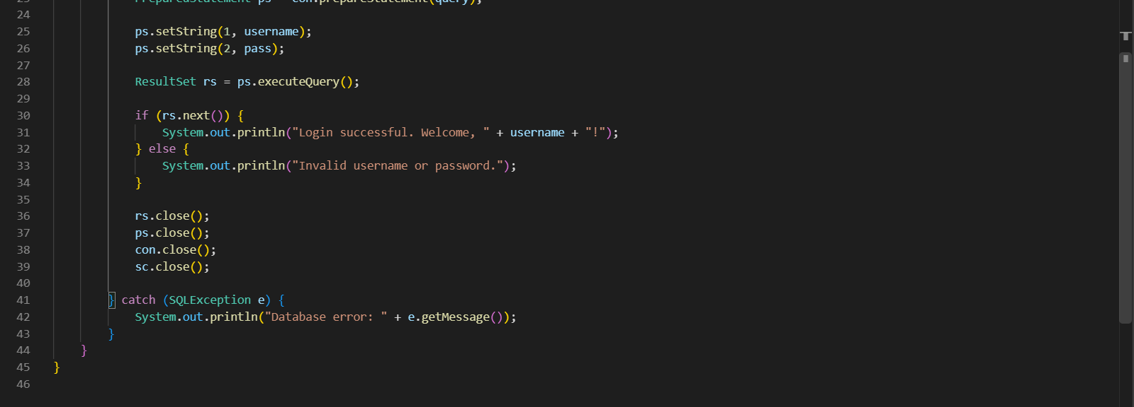
Output
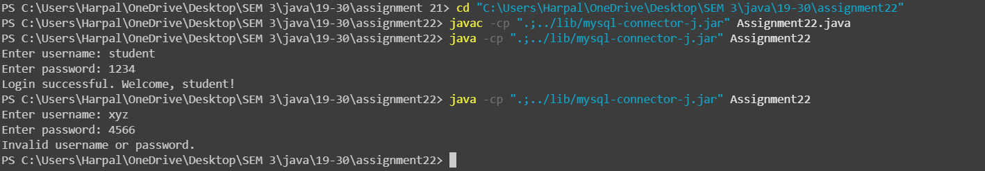
Conclusion
The program demonstrates the use of PreparedStatement and ResultSet for secure database queries and record retrieval. It verifies login credentials stored in MySQL and displays the appropriate authentication message.

